The assignment is the exercise described below.
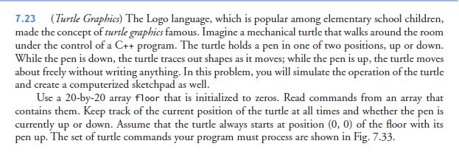
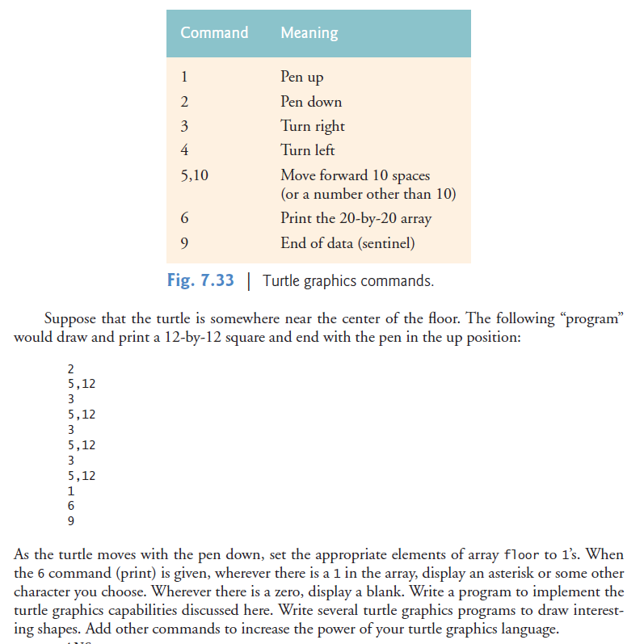
The information supplied above is a screenshot taken from an earlier version of the text. You will not find this exercise in the current version of the text. When I refer below to “the text”, I am referring to the screenshot above.
I want you to create a class called TurtleGraphics for this assignment. At a minimum, this class must have the following 3 member functions:
TurtleGraphics(void); //ctor
void processTurtleMoves( const int commands[]);
void displayFloor() const;
I have created the main program (Assign6.cpp) and the class interface file (TurtleGraphics.h) for this assignment and put them in folder "Start using C style array". You may add additional members and functions to the TurtleGraphics.h file. My solution contains additional member data and functions . You must not modify Assign6.cpp, except to uncomment one additional line of commands or to add alternative command sets - more about that below. Note: you will also need to modify these 2 files when converting from traditional C style arrays (aka built-in arrays) to C++ 11 STL arrays. I have also put in the start folder the file "Sample Output.doc", which shows what your output should look like.
When you look at TurtleGraphic.h, you will see that the class declares several data members with the keyword static. A static data member is what is called a "class variable" in Object Oriented Programming (OOP) languages. There is only ever one instance of a static data member. A static data member has class scope. OOP programmers generally use a class variable, where a C programmer would use a global variable. This is why C++ programmers rarely need to use global variables. Case study "7.6 Case Study: Class GradeBook Using an array to Store Grades" that we covered in class contains an example of a static data member.
This assignment requires the use of a multidimensional array. You may want to review section 7.8 of the text to remind yourself how multidimensional arrays work in C++. You will need two arrays as part of your solution.
One array will contain the commands that the turtle must execute. The beginning of the initialization of the "cmds" array looks like this:
int cmds[] = {5,5,4,5,9,2, ... // If you look at the table of commands in the text, you will see that these commands will cause the turtle to move forward 5 spaces, turn left, move forward 9 spaces and then put the pen down (it is now ready to start drawing the first 'B' in "BOB" ).
The second array will be a 2 dimensional array called "floor" which will be used to represent the floor that the turtle is writing on. The text suggests that the floor array should be 20 by 20, but I am requiring that you use a floor array with dimensions 22 rows and 70 columns (the output looks better using these dimensions).
Some additional clarifications:
- Assume that turtle is pointing south at the start. The text has already specified that the turtle starts at position 0,0 with the pen up.
- When you move forward with the pen down, the final position should not have its position in the array "floor" set to true (be written on by the pen, in other words). For example, if the turtle is currently in location 3,5 (3 represents the 4th row and 5 represents the 6th column because as usual with arrays in C++, we start counting at 0); the turtle is currently moving east (to the right); and the command is 5,3 -- then the turtle will move from cell 3,5 to cell 3,8, but only cells 3,5, 3,6 and 3,7 will be written on by the pen (have their boolean value changed to true, if not already true). This is to avoid writing more than once to the same cell (not a problem, just not efficient). Having said that, you do _NOT_ need to test if a position on the floor is already set to true before setting it to true.
- Ignore (or shorten) any command that will cause the turtle to go off the end of the floor. For example, if turtle is asked to move 5 spaces, and only 4 spaces are left to move in the current direction on the floor, only move the 4 spaces available. Again, in this example, do not write in the cell where the turtle stops (as specified in the previous point).
The main program I have provided has the commands required to produce the output shown in the sample output. I have commented out one line of the commands, because it is the most difficult to process correctly. The commented out line of commands tests whether your program handles correctly commands which would have the turtle go out of bounds (go off the 22 by 70 floor). First get your program to output "BOB" correctly; then work at getting your solution to process the commented out line of code. When the commented out line of code is uncommented and correctly processed, the outer border shown in the sample output will be drawn.
NOTE: I would like you to produce a solution first using traditional C-style arrays, for loops and enum types. Once your solution is working, I would like you to make the changes required to convert your solution to use:
- C++ 11 STL array (as demonstrated in the course Chapter 7 slides). You should convert both the 1D and 2D arrays. You should _NOT_ use STL vector for either 1D or 2D arrays.
- range based for loops, where practical, where you previously had used regular for loops
- scoped enum with an underlying type of unsigned short where you had previously used regular enum types
These changes will require you to change the TurtleGraphics.h and Assign6.cpp files as well. You may wish to rename the enum type to something shorter such as “Cmds”. You can assume that the array containing the commands will have 250 or less commands. I have supplied the starting point for doing the assignment the "C++ 11 way" in the folder "Start using STL array". Only look at this starting point if you are having problems doing the conversions on your own.

PLEASE NOTE:
===========================================================================
You will need to cast the cmds (which are of type int) into type Cmds in order to avoid error indications in MS VS 2013 or MS VS 2015. So you will need something like:
switch ( static_cast<Cmds>(current_cmd)) { // Switch statement start
If you don't cast, you will get an error indicated (by red squiggly lines under the code) with the different cases in the switch statement such as: case Cmds::PEN_UP:
What I found curious is that if you ignore the error indications and compile and build the code, it does so without errors ?!?! Some kind of bug in MS VS I assume.
===========================================================================
NOTE: I only want you to submit for marking the solution using the STL array, range based for loops, etc.
NOTE: Test your final solution in "Release" mode and _NOT_ "Debug" mode if you are using Microsoft Visual Studio IDE. The debug mode will perform automatic initializations that you should not be depending on!
NOTE: Initialize your class data members in the class constructor and _NOT_ in the class interface file.
Hint: Your solution should make use of several switch statements!
PLEASE NOTE: YOU MUST FOLLOW THE INSTRUCTIONS BELOW FOR _ALL_ OF THE ASSIGNMENTS IN THIS COURSE:
1) Submit your solution to the D2L drop box before the deadline. The solution must include a soft copy of the test output produced by your solution. Please study carefully the document "How to submit to D2L.txt" . If your solution does not compile or build, supply a soft copy of the error messages instead of the test output. I will provide separate instructions on how to create a soft copy of test output - "How to Save a Soft Copy of the Contents of the Console Window.txt". If I do not provide you with the test data for an assignment, you must create your own test data that proves your solution works as designed. This may require you to execute your solution several times, each time saving the output your solution produces to the "Test Output.txt" file you will hand in with your solution. If you do not submit your solution to the D2l drop box before the deadline you will receive a mark of 0 on the assignment. No exceptions!
2) You must hand in a hard copy (a printout in other words) of the code that you wrote or modified (the .h and .cpp files). You must also include a hard copy of the test output as well. If your solution does not compile or build, supply a hard copy of the error messages instead of the test output. These must be handed in at the beginning of class.
3) THE HARD COPY FILES YOU HAND IN AT THE BEGINNING OF CLASS MUST MATCH EXACTLY THE FILES YOU SUBMITTED TO THE D2L DROPBOX BEFORE THE DEADLINE. IF I BELEIVE THAT YOU HAVE HANDED IN WORK DONE AFTER THE D2L DEADLINE, YOU WILL RECEIVE A MARK OF 0 ON THE ASSIGNMENT.
4) You risk losing marks if your output is not formatted identically to the sample output or .exe I provide for an assignment. Disregard this warning at your own risk.
5) The coding standard you are to use for this and future assignments is in ShareOut. It is in the file "2617 Coding Standards.doc".
6) The generic marking scheme that will be used is also in ShareOut - it is the file titled "Generic Assignment Marking Scheme.doc". I will provide the specific marking scheme I used to mark an assignment when I return your marked assignment to you.
If you have any questions, post them on the D2L Discussions Assignments board or send me an e-mail.

